# PLAYWRIGHT

# Playwright

# Application supported:

## Supports web application, API testing, Browser based mobile application but not support Mobile Native apps.

# Languages:

## JavaScript, Typescript, Java, Python and .Net(C#)

# Browsers(headless/headed):

## Chromium – Microsoft Edge, Opera, Brave, Chrome

## WebKit(Safari) – For Mac users

## Firefox

# OS Supported

## Windows

## MacOS

## Linux

## Support CI Runs

# Features

## Free – No need to buy any license, anybody can install and use it.

## Open Source – Customized tool(you can add some more features or third-party library and contribute time and effort)

## Supports multi language, multiple browsers, multiple OS.

## Easy setup and configuration

## Supports Functional, API and Accessibility Testing(but to use third party plugin)

## Built in reports available-We can automatically generate reports.

## Also generate custom reports.

## Supports CI, CD, Docker.

## By default, support Parallel testing(Selenium we must depend on TestNG)

## Built-in Auto Wait mechanism.

## Built-in Assertions(Selenium we must depend on TestNG assertions)

## Multi Tab, Multi window support and Frames

## Identify Shadow DOM elements.

## Supports Parameterization.

## Emulate Mobile devices.

## Execution is very faster than another tool.

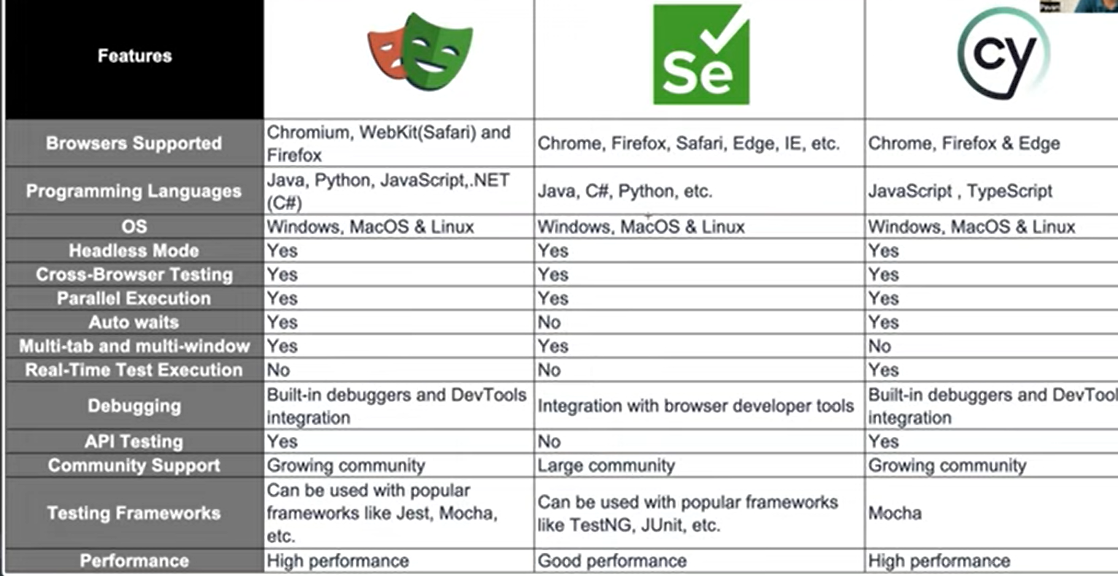

# Installation and Setup

# Prerequisite

## Node.js (by default you will get npm node package manager)

## Once installed check the version.

node –version or node -v

npm –version or npm -v

## Visual Studio Code Editor

## Create Project Folder -> Open it in VS code.

# Install Playwright using Command Prompt

npm init playwright@latest

## Once installed check the version

npm playwright -v

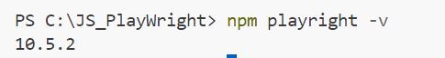

# Install Playwright from VS code extensions:

## Click on Extension Icon->Type playwright in the search bar-> Select “**Playwright Test for VS code**”-> Click Install

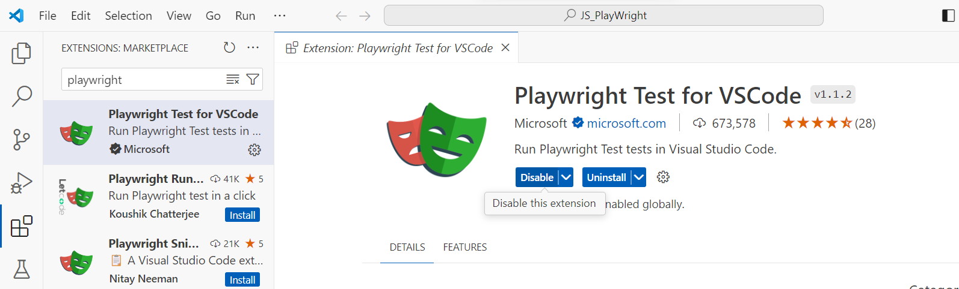

## Go to Project Explorer-> View-> Select Test: Install Playwright

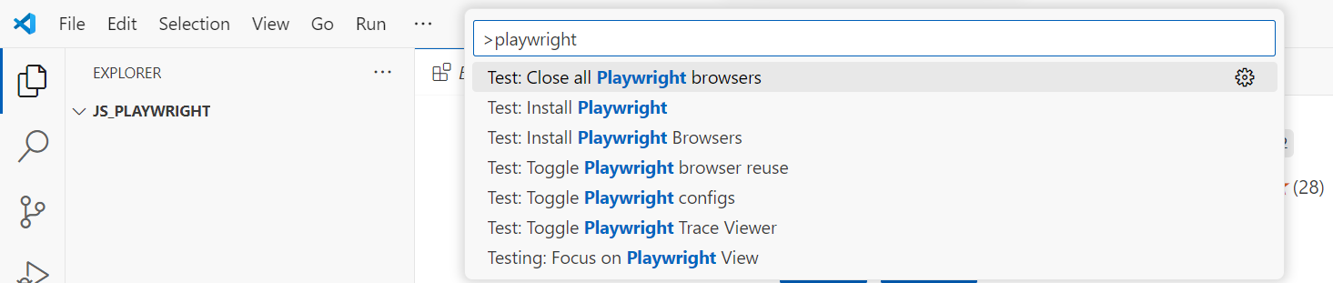

# Installation begins:

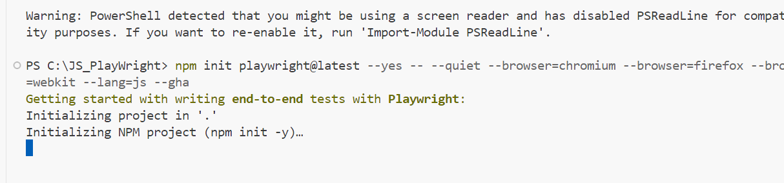

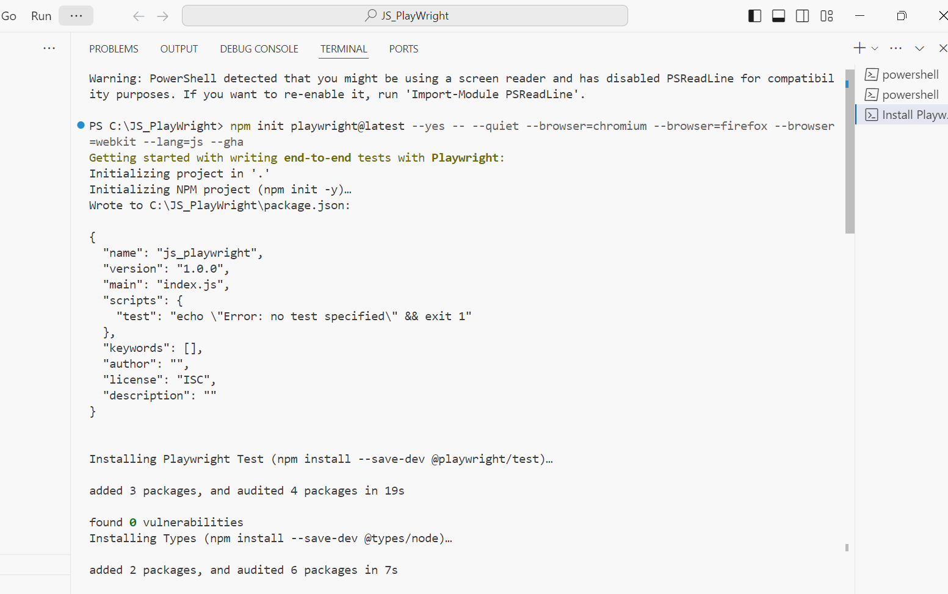

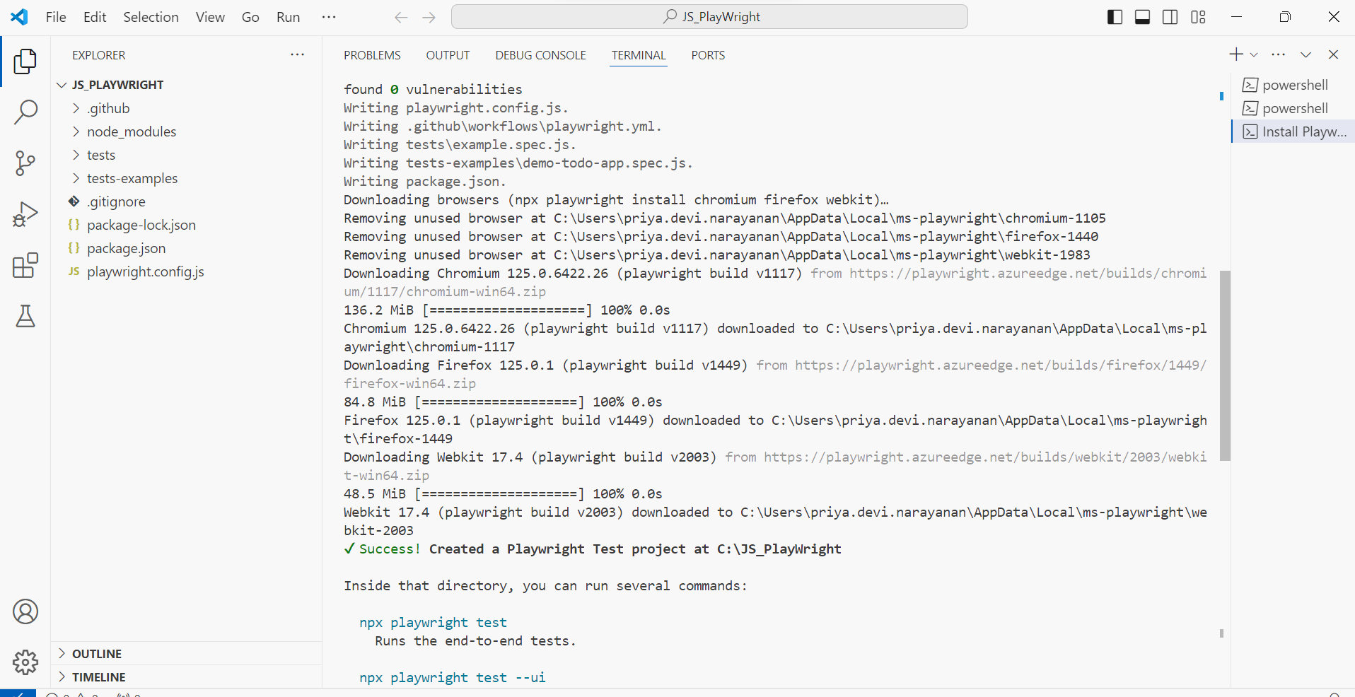

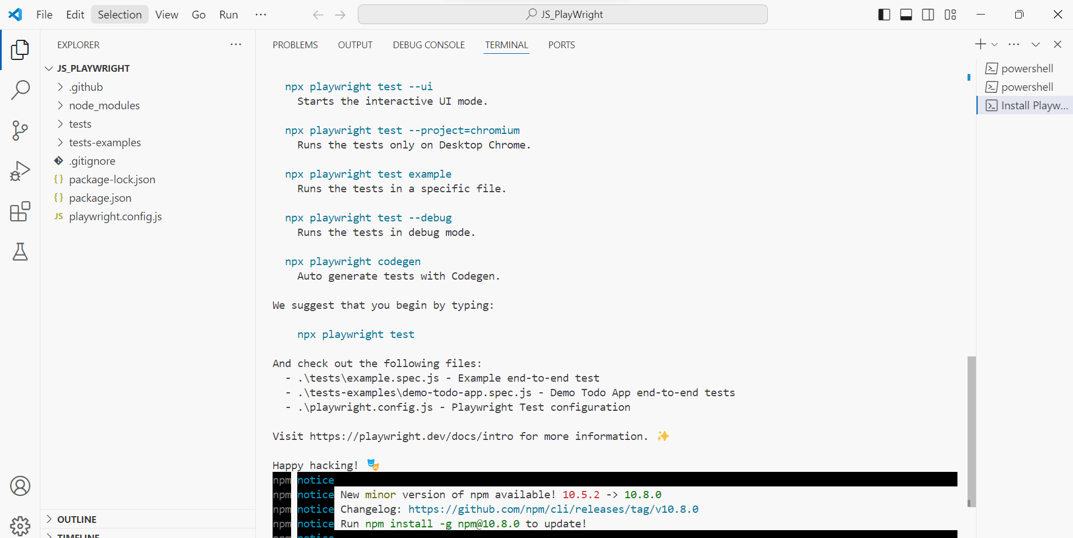

## By default, all tests will get executed in headless mode by playwright.

## Run playwright test.

# Execute in Headless mode:

## npx playwright test

## By default, it will pick all the tests which are presented under tests folder and execute.

# Execute in Headed mode:

## npx playwright test –headed

# To show HTML reports

## npx playwright show-report

# Project Folder Structure

# playwright.config.js

## This file will manage the project configuration.

## Playwright configuration.

# package.json

## Specify all dependency module required in playwright. It’s like pom.xml.

## Node project management file.

# Tests

## All test script files.

# Create and Run Playwright Test

# Two Approaches

## Using Codegen

## Not using CodeGen

# Approach 1: Not Using CodeGen

## We must import this playwright test module in our test file and then we will be able to access functions and fixtures.

## To **import** we must use one **function** called **require** and this comes from node js.

## Inside require we must specify the module we want to import.

## This module again there are so many packages are available. We need only two packages. They are expect and test.





## To write the playwright test - **test**

## To add validation, we need one more package – **expect**

## These two **“test and expect**” are **constants** so we can use let, var or **const**.

# Write Test

## To start writing our test we need **test block.**

## It contains two parameters.

## **First parameter** -Title for the test

## **Second parameter** – Anonyms/Arrow function

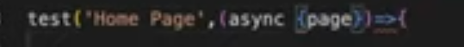

## Whenever we create arrow function, we must pass fixture called {page} and keyword async..

## What is fixture-> It contains so many functions and through that we can automate web application.

## All the commands are available in this page fixture.

## By using this page fixture, we must access all commands(launch browser, click on elements, get text from page etc..).

# Open application URL on browser:

## Whenever we are accessing a method from page then we must mention a keyword called await.



## JavaScript asynchronized programming language.

## In your code you will have multiple lines so the first line of code should complete its execution and then it must proceed with next step.

## But in JavaScript it executes parallelly no step depends on or wait for any other step to complete.

## But in automation we must execute sequentially. So, to make it happen we must handle called promise.

## **async** keywork : Makes the function return the promise. Until the promise returns the next await method will not execute the command.

## **await** keyword : Makes the function wait for the promise.

## goto statement will wait till the page is loaded then only next command execute.

# page.title() -> return the title of the webpage.

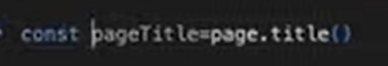

# Capture title



# Validate the title:

## Expect is the method to validate.



# Validate the URL:



# To close the page

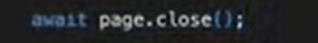

# To execute specific test and specific browser



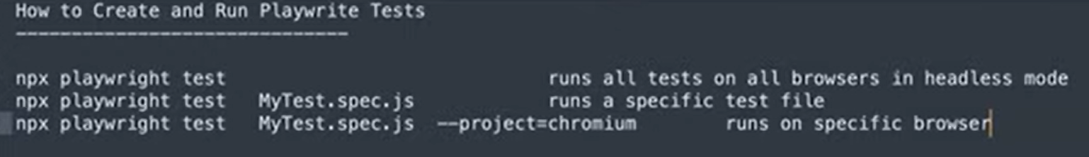



# Locating Elements

## Property

## CSS

## XPath

# Locate Single Element

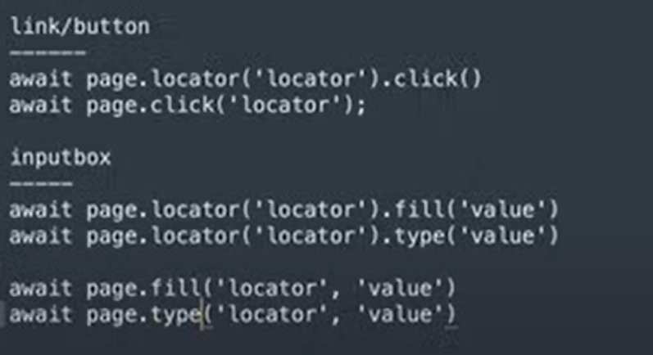

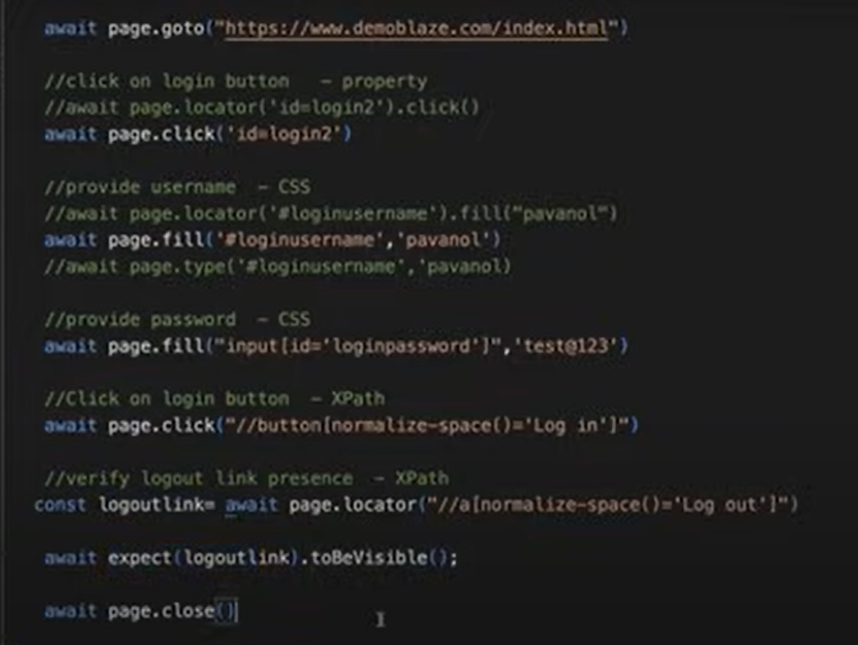

## toBeVisibile() – To validate whether the element is visible in the web page or not.

# Locate multiple Web Element

## If we want to locate multiple elements, we must use $$ symbol.

## With this we captured all the products and now we must store them in a variable and the type of the variable is constant.

## Now we need to read each product element from that we need to extract the product name.

## For each loop is used to iterate through the products.

## Now must capture the text of the products for that we have to use the method **textContent()**

## **textContent** -Get text value of the element. In JS we have to use **of** in for each loop.

## Single quotation inside single quotation not allowed and double quotation inside double quotation not allowed inside brackets.

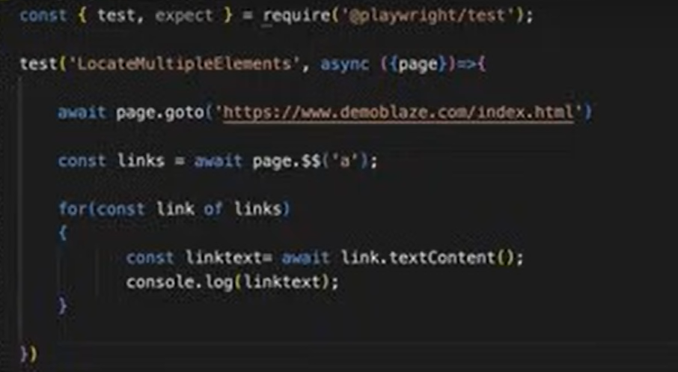

## This will return all the links present in the page because we specified with anchor tag.

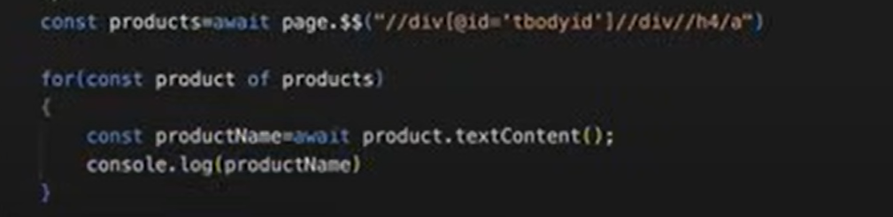

# NOTE: The locator specified inside $$ should be able to match multiple web elements. If the locator is not matching with any web element, then it will simply return empty [].

# Additional Built-in Locators in playwright

# page.getByAltText()

## To locate an element usually image, by its text alternative.



## If any element is having this **alt** attribute, then we can easily locate the elements by using getByAltText().

# page.getByPlaceHolder()

## To locate an input field by placeholder attribute.

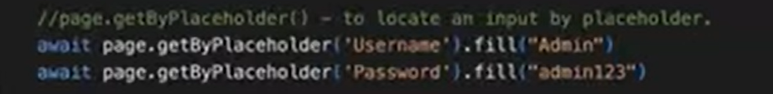

# page.getByRole()

## To locate by explicit and implicit accessibility attributes.

## Role is not an attribute here.

## Locate the element by its role of button with type "submit".



# page.getByText()

## To locate inner text of the element.



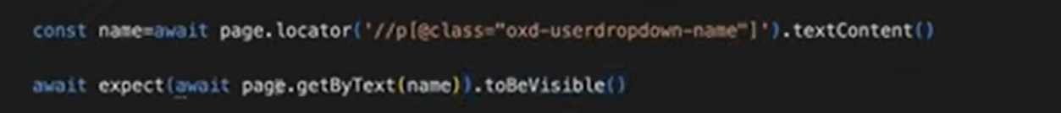

# page.getByLabel()

## To locate a form control by associated label's text.

## If the element has label attribute, then you can use this method to identify that element.

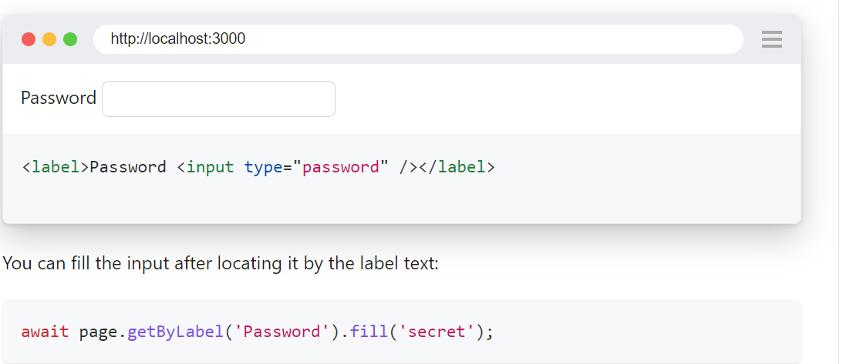

# page.getByTitle()

## To locate an element with a matching title attribute.

## If the element has title attribute, then you can use this method to identify that element.

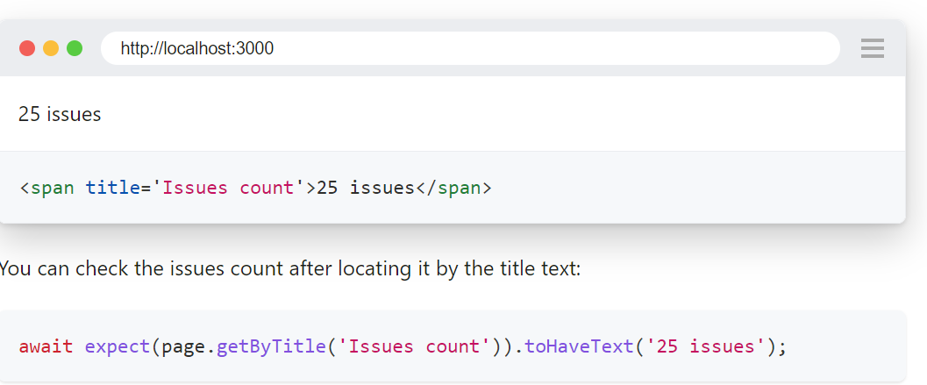

# page.getByTestId()

## To locate an element with data-testid attribute.

## If the element has **data-testid** attribute, then you can use this method to identify that element.

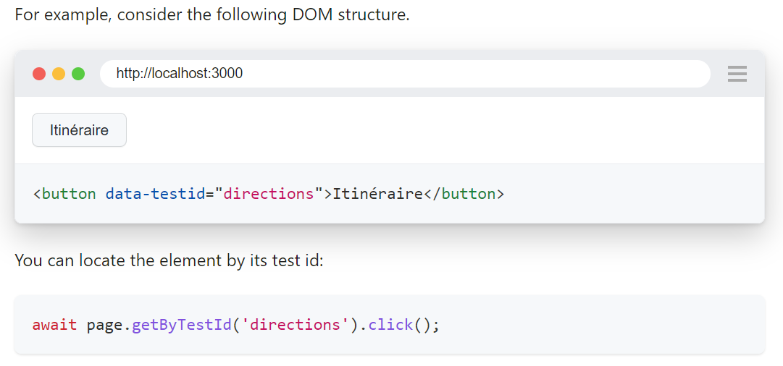

# Approach 2: Using CodeGen(Test Generator)

## In Terminal run the below command

npx playwright codegen

## Playwright inspector will get automatically opened along with the browser window(chromium by default).

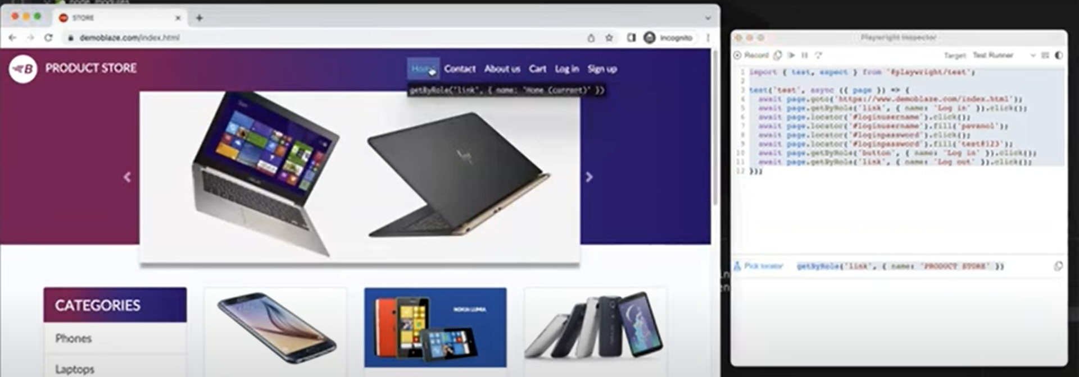

# Features(Options)

## Using Pick Locator icon at the bottom we can identify elements in the browser page.

## We can also convert the generated code to other language by selecting the respective language in inspector.

## Instead of copy pasting manually the recorded code in test file our command itself will create test file and paste the generated code into it.



## Automatically generate the code in the specified language.



## Open the Mobile browser.

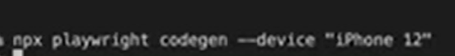

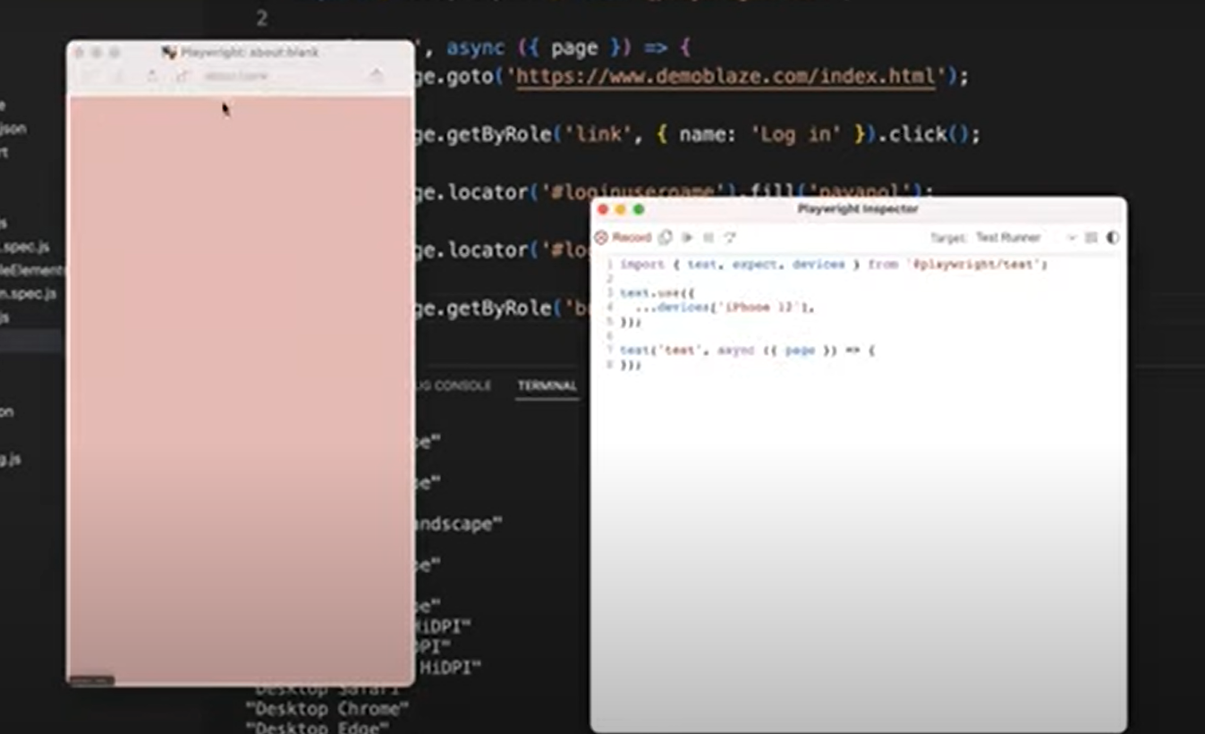

## Set viewport size.

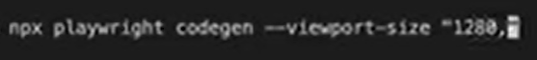

# Assertions

## To perform some validations.

# Hard Assertions

## If any assertion got failed, then it will not execute the rest of the code(next step/assertions) in the same script.

## It will terminate your code.

## After assertion whatever code you have written it will not get executed.

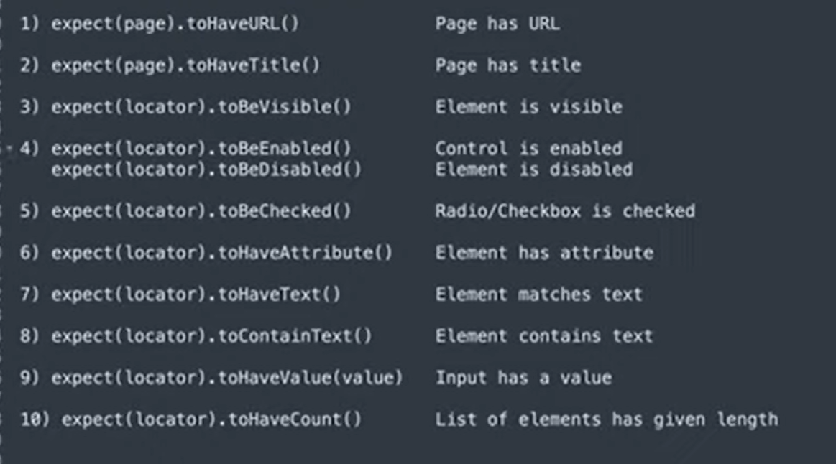

# Element is visible or not:

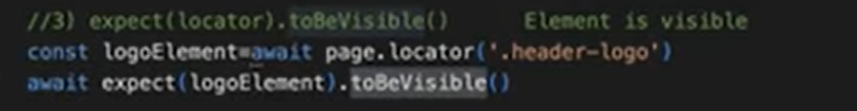

# Element is enabled or not:

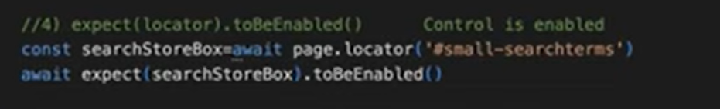

# Radio/Checkbox to be checked or not:

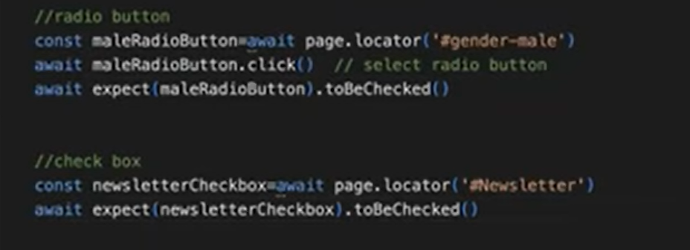

# Element has attribute or not:

## Captured the element and verifying whether the element is having particular attribute or not.

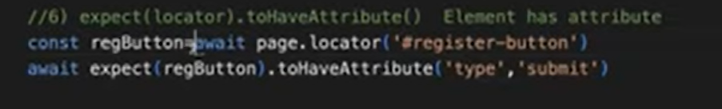

# toHaveText()

## Checks for the exact match of text.

# toContainsText()

## It will check for the partial match of text.

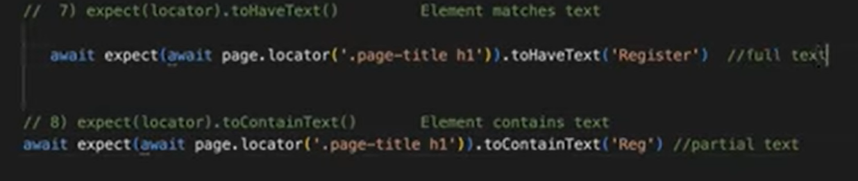

# Input box has value or not:

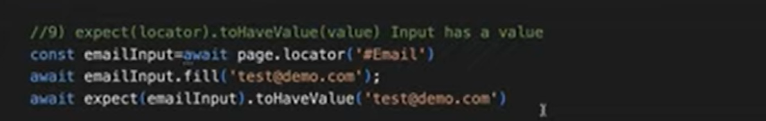

# toHaveCount()

## Especially this will be very useful for dropdown. If we want to count how many options are there in dropdown by using this assertion.

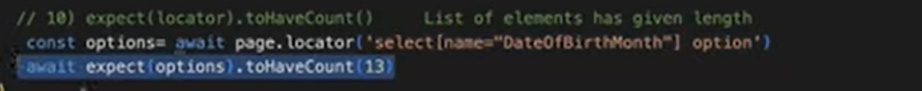

# Negative matches

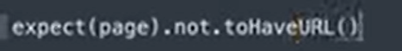

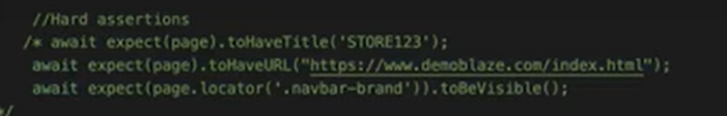

# Soft Assertions

## Even though assertion got failed it will not terminate the execution still it will execute the rest of the statement/code.

## But it records the test as failed.

## After assertion whatever code you have written it will get executed.

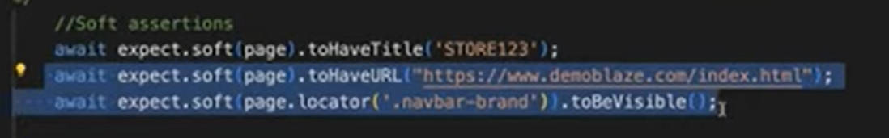

# Handling input box

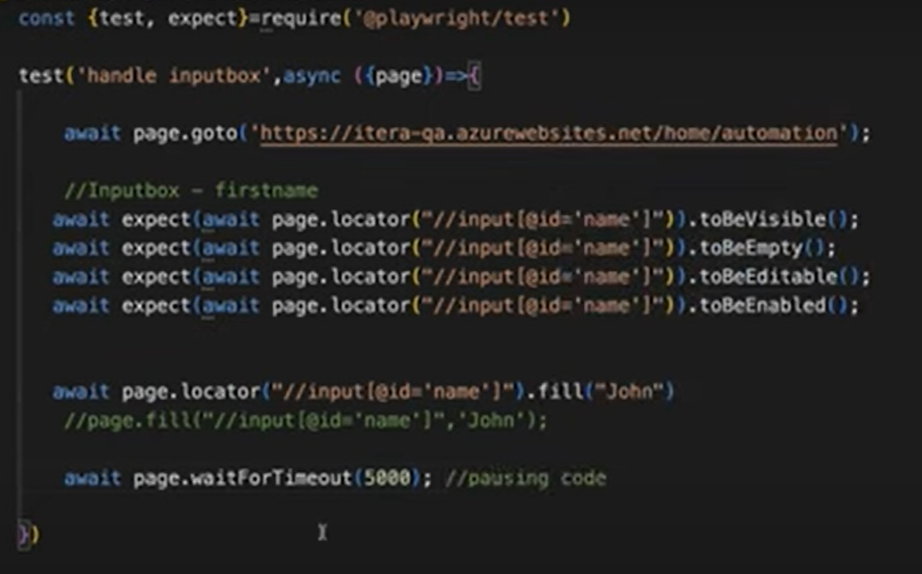

# Handling radio buttons

## isChecked() – This will return true if radio button or checkbox is checked and that Boolean value will be again compared with tobeTruthy() method(this will return true). If both are same then it is passed else assertion will be failed.

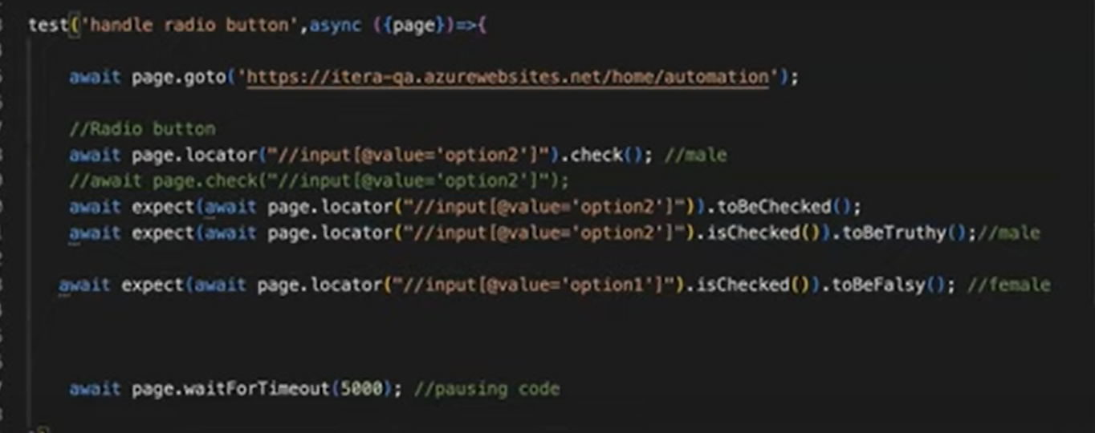

# Handling Single Checkboxes

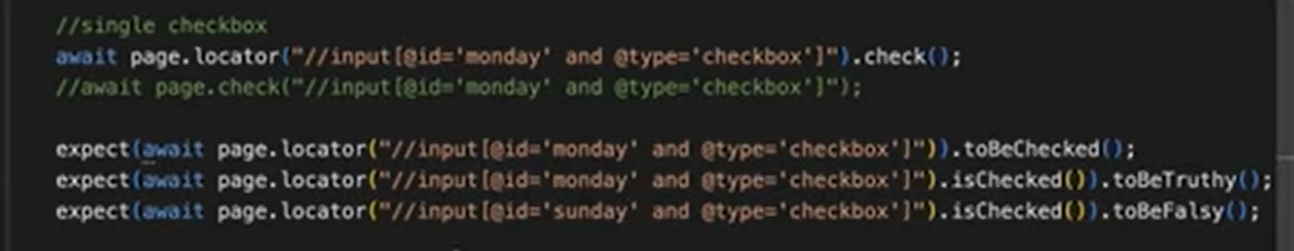

# Handling multiple checkboxes

## If we want to select 3 options from the checkbox.

## First, we must find the locator of three text boxes and store them inside the array.

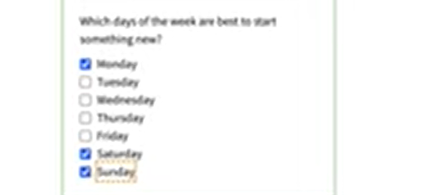

## Maintain the locators inside the array and write looping statement(in for loop iterate) and check the locators

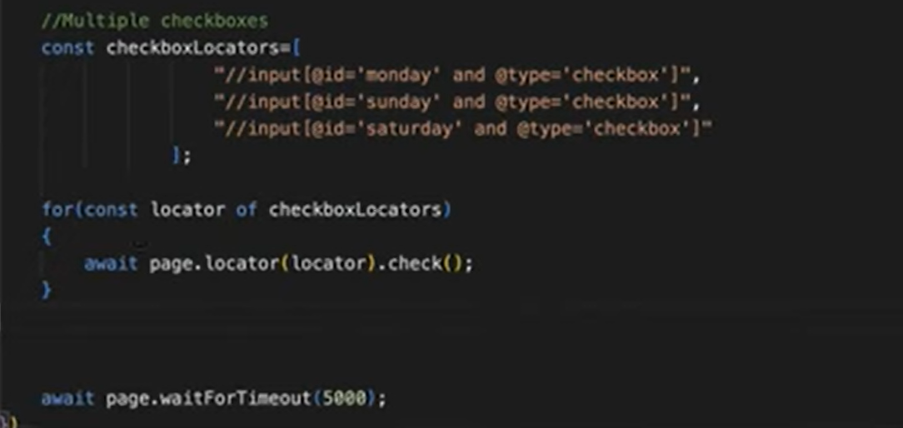

# Uncheck

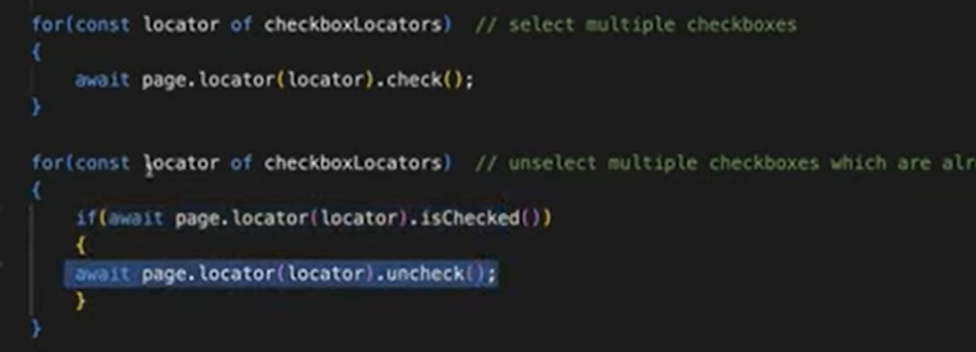

# Handle Dropdown(select one option at a time)

## Using selectOption() method.

## This method has different parameters whether we can select by label, visible text, value or index.

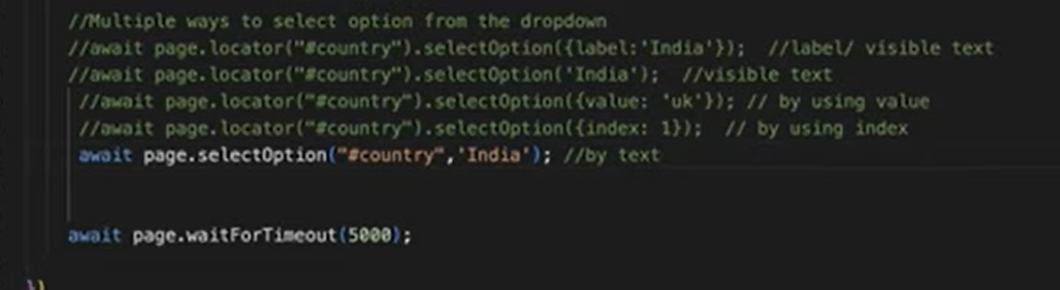

# Assertions on dropdown

# Approach 1:

## We will not get this in array format.

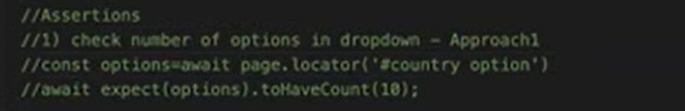

# Approach 2:

## If we want to get all the elements in array format, then we must use $$.

## It will print how many options are there in the array using **length** .

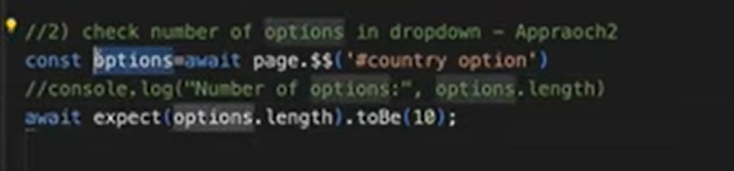

# Approach 3: Without Looping

# To check the presence of specific value in the dropdown

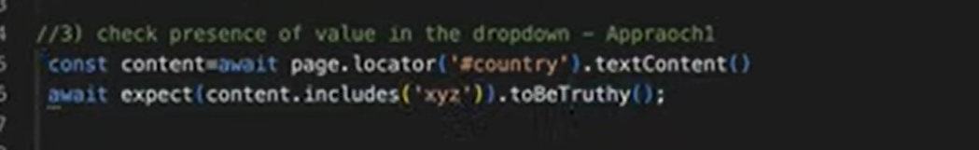

# Approach 4: With Loop

# To check the presence of specific value in the dropdown

## Capture all the dropdown elements and store it in a variable.

## Extract text from that web element

## Whenever you want to change the variable status don’t make that as const variable. Let status= false;

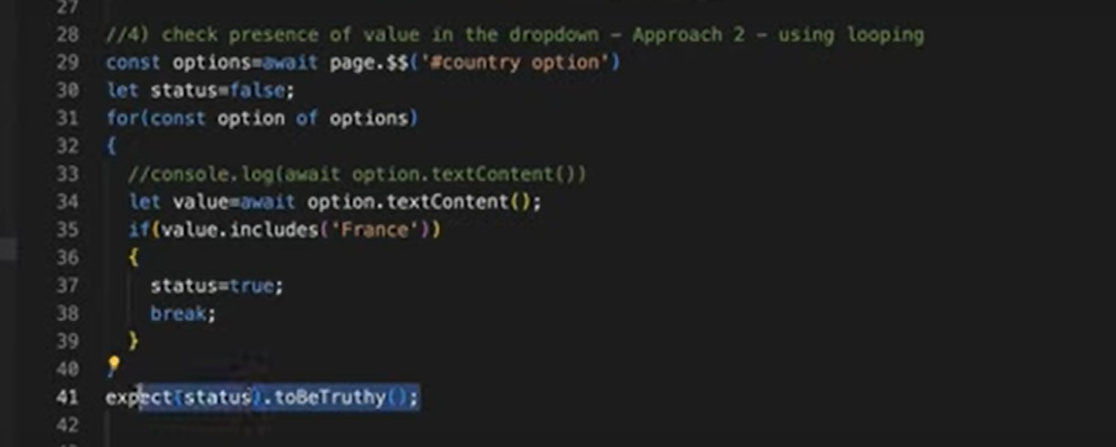

# To Select the option in the dropdown

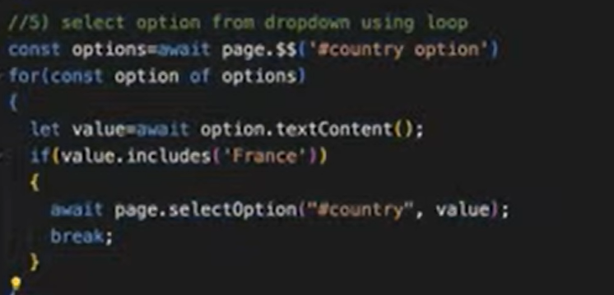

# Handle Multi Selection Dropdown:

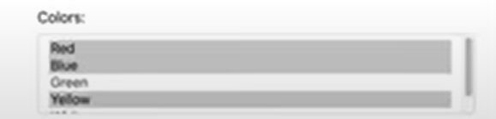

## toBe and toHaveCount both can be used to validate the count.

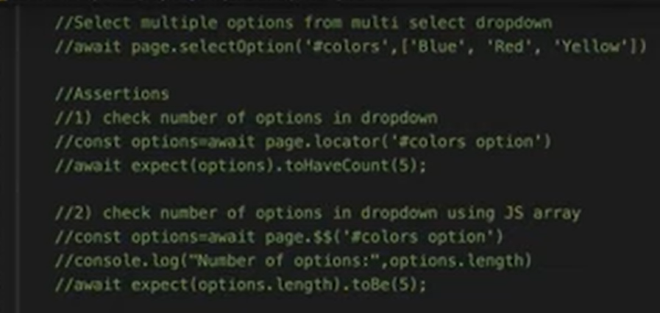

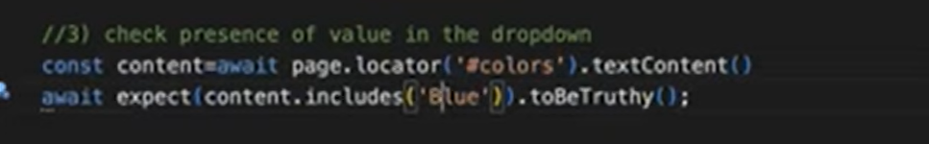

# Handling BootStrap Dropdown

## It does not have select tag.

## We can select single or multiple options.

# To check Total number of options in the dropdown

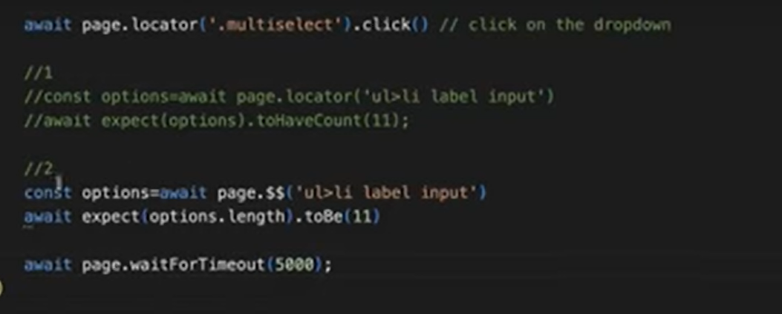

# To Select options in the dropdown

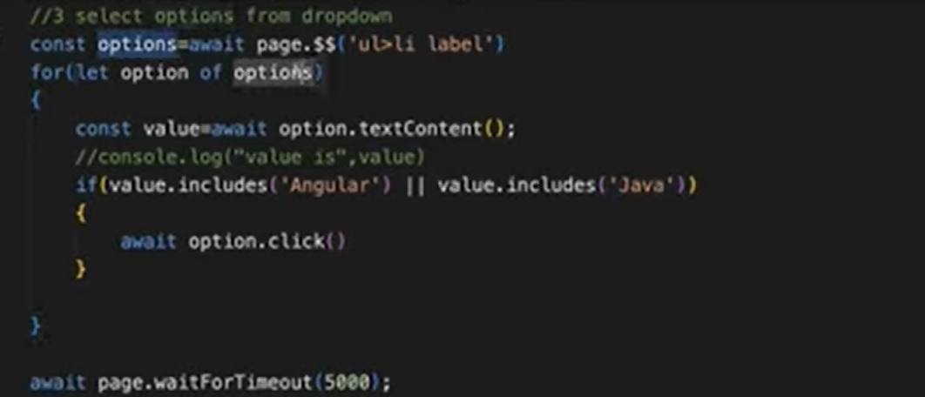

# Handle Autosuggestion dropdown:

## When u enter some value, it will give some autosuggestions from that we have to select the option.

## Even it will take some time to load the options to be displayed.

## Even dynamically the order of the options will also be changes.

## **waitForSelector** – wait until the all the elements get loaded in page.

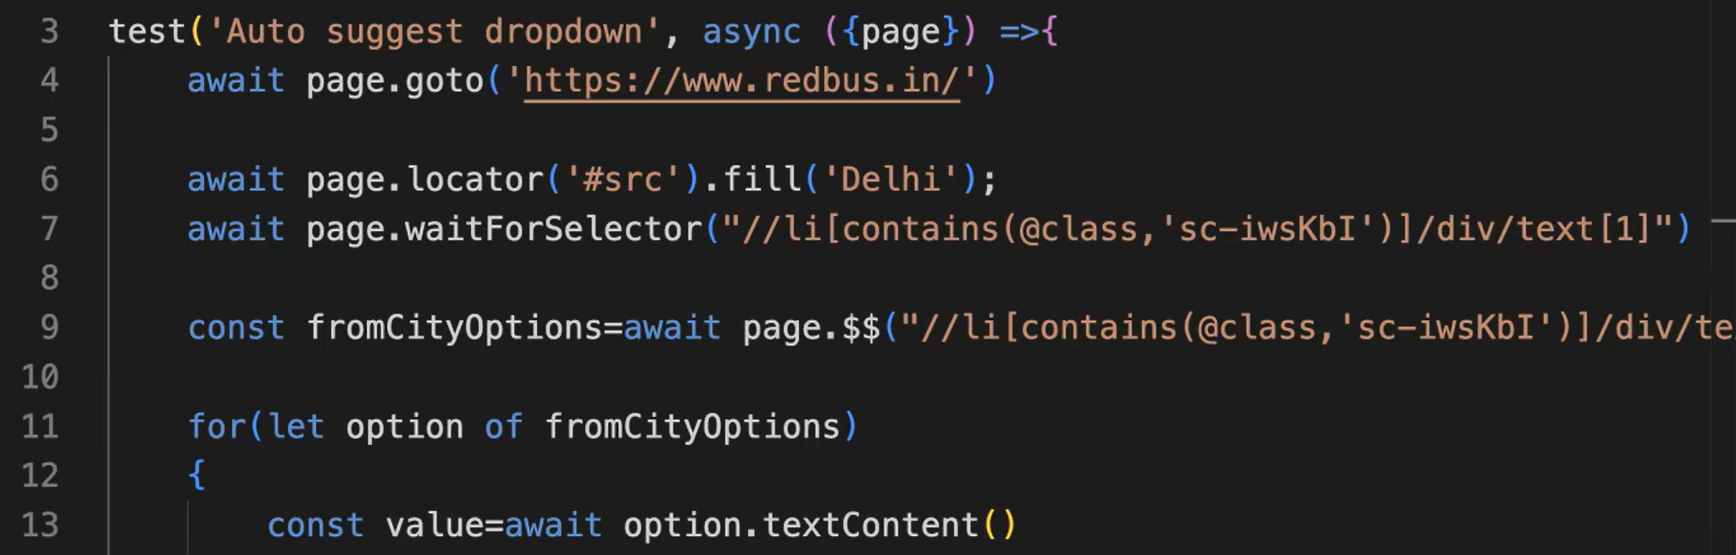

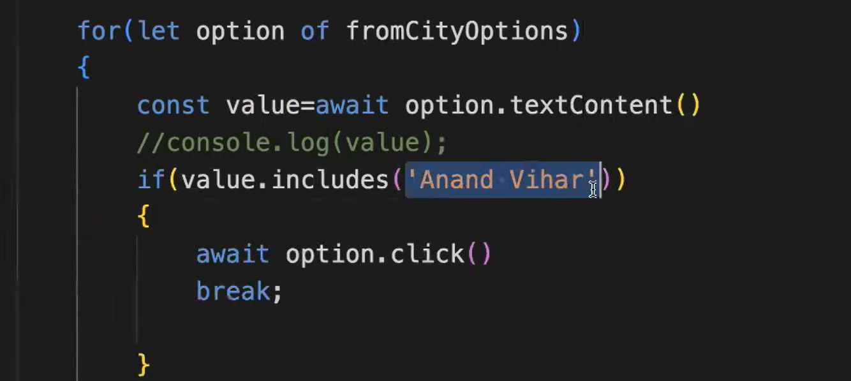

# Handling Hidden Items in dropdown

## The dropdown contains the options but most of the options are hidden. We cannot directly inspect those options.

## When we right click to inspect it will disappear.

## Debugger option in selectorHub tool is very uselful when dealing with hidden items.

## Turn on Debugger. After click on the element and It will freeze the page.

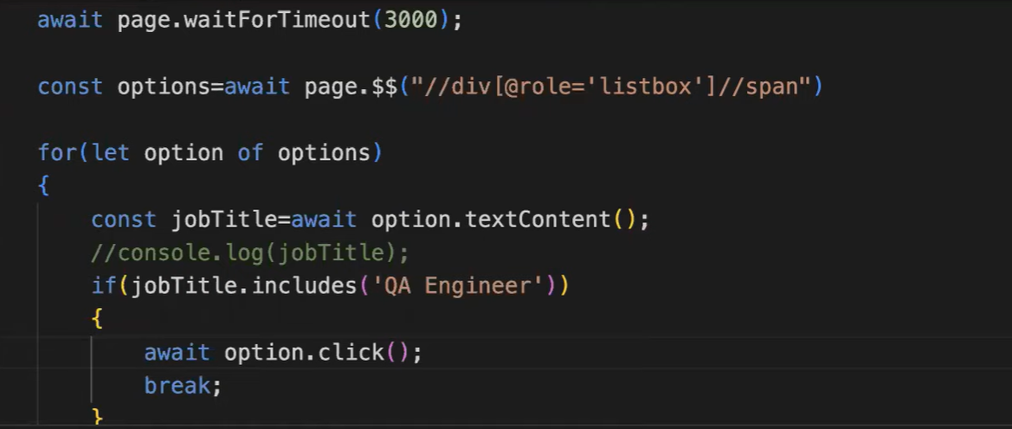

# Alerts(Dialogs)

## Auto dismissed by playwright. We don’t have to handle them.

## If we want to handle any validation, then we have to enable dialog window handler.

## To write dialog window handle we need to first enable alert handle.

## Specify keyword dialog in on function and receive that keyword in one more variable called dialog.

## Type() says what type of alert it is.

## Suppose if I want to verify message in alert then use message ().

## Accept() – to click ok and close alert.

## Before alert window open we have to enable this

# Simple Alert

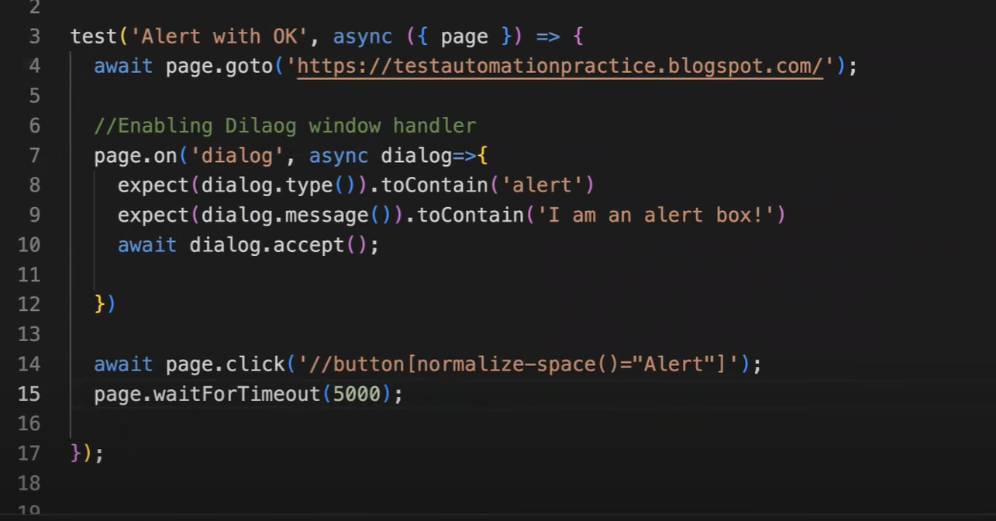

# Confirmation alert

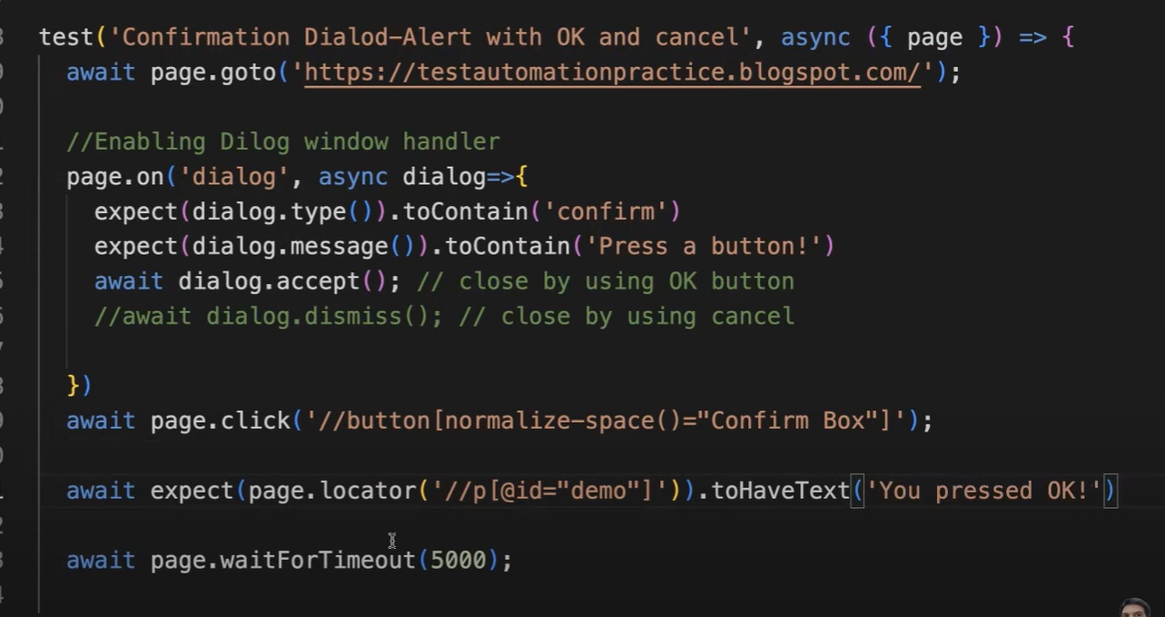

# Prompt Alert

## But we must enable this dialog window handler because we have to do certain validations on that.

## So before opening the alert window the event should be triggered that why we have to enable the dialog window handler before clicking on the button.

## Returns defaultvalue which is present inside the input box.

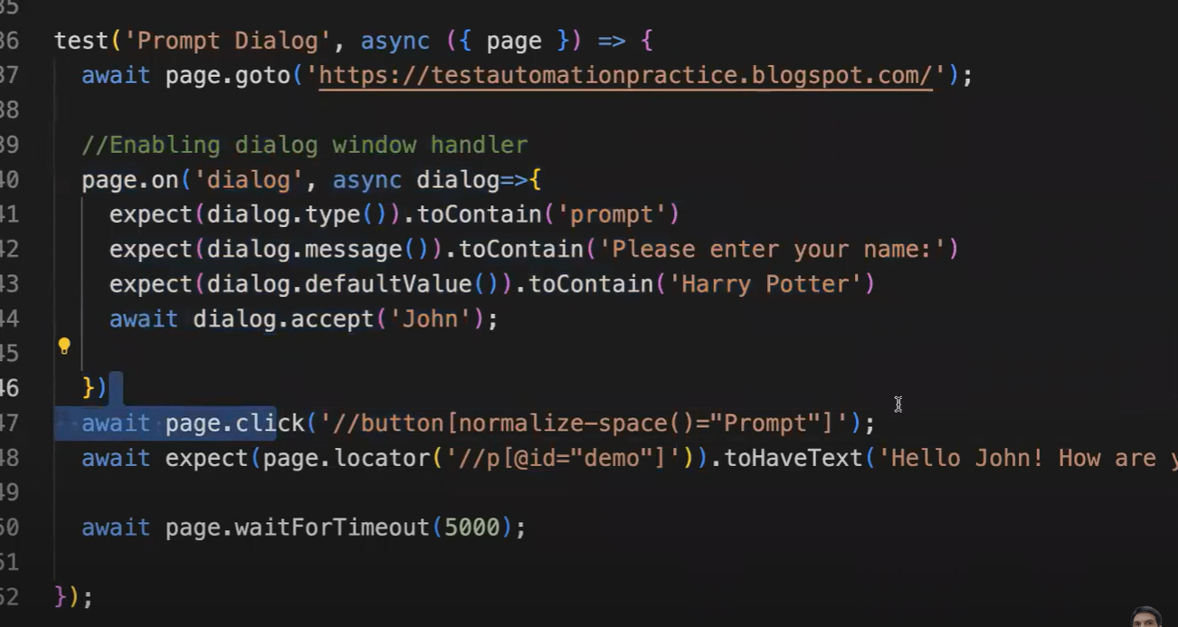

# Handling Frames

## One HTML embedded with another HTML page.

# Two Approaches

## First get the frame by using framelocator()

## Using frame method(Path the name or URL of the frame) then only we can access the elements inside the frame.

# Approach 1: Using frame()

# To return all frames in page(array of frames)

## frames()

## frames() will return the frame and will store it in variable.

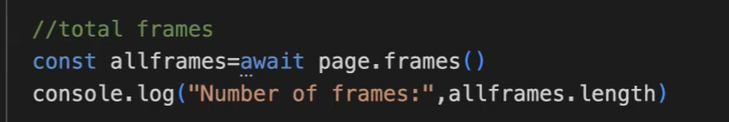

# A screen shot of a computer code Description automatically generated Approach 2: Using framelocator()

